**Basic Fitting Work (6 Month) & Fitter and Fabrication (1 Year)**

**Duration - 6 Months & 1 Year**

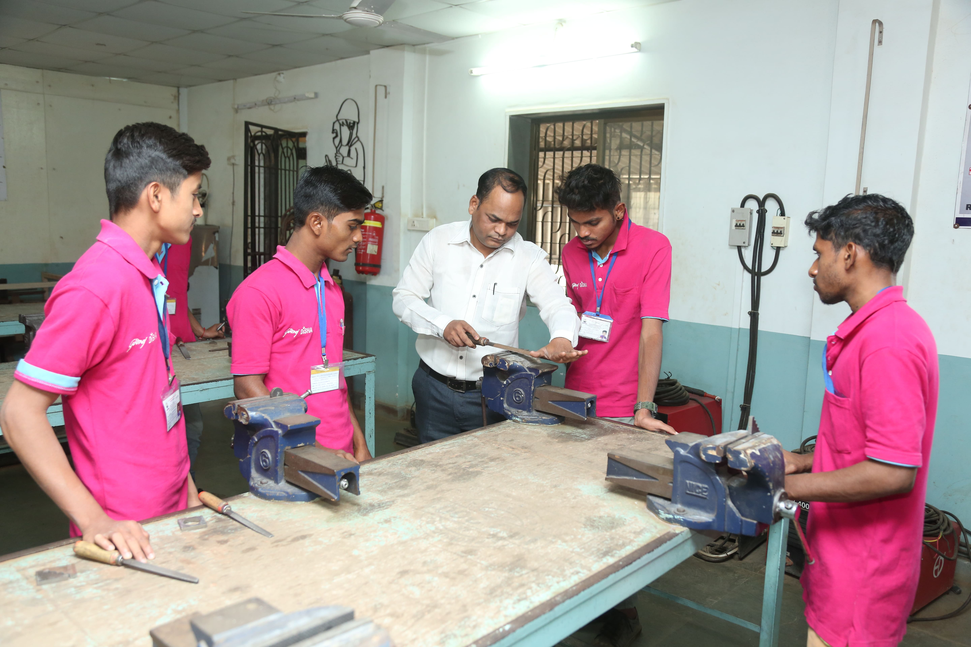

|  |  |
| --- | --- |
| COURSE OBJECTIVES & CONTENT | ELIGIBILITY |
| **•** Candidates should be able to enjoy technical work, physically fit; good hand-eye coordination; able to work independently or as part of a team; practical ability and an eye for detail.  • They must be aware of safety regulations such as wearing personal protective equipment during working hours.  • They should possess physical strength and stamina and be able to work in uncomfortable positions  • They can find jobs in production and manufacturing industries; structural fabrication like bridges, roof structures, building & construction; automobile and allied industries and service industry is like road transportation and railways  • Fitter Trade pass students have bright scope in shipbuilding and repair; infrastructure and defense organizations; public sector industries like GODREJ, JSW, TATA STEEL, etc. and private industries in India & abroad  **The course curriculum covers the following topics:**   * Basic Fitting & Structural Fitter * Machine Assembly & Maintenance * Pipe Fitter * Oxy Fuel Gas Cutter * MMAW/SMAW Welder * Soft Skill Training and Other Activities * Examination * Implant Training | * Education - Class 8th * Minimum age – 17+ years |
| CERTIFICATION |
| * Certificate issued by Fr. Agnel & Supporting / Funding Partners (Godrej & Boyce Ltd.) * Certificate issued by the on-job Training Partner * Certificate issues by Govt. if batch is under MSSDS. |
| FACILITIES |
| * Basic skills lab with Machines & Tools, Structure Fabrication, Pipe Fabrication, Maintenance * We have long Standing relationship with a number of local suppliers. * Installation, repair, maintenance and manufacture of Mechanical Systems as required of Manufacturing Industrial * English spiking Training and Soft Skills Training, Allied Trade Training, |
| ON JOB TRAINING / INTERNSHIP |
| * Mandatory minimum 2 month long supervised on-job training/ internship at a reputed company |
| OTHERS |
| * Weekly Exam, Weekly Student-Centered Activities, Quarterly Projects, Monthly Guest Lectures, Industry Visit, Market Visit, Various Workshops, etc. |
| PLACEMNT SUPPORT |
| * Campus Interview, Job Fair, Placement Assistant, etc. |

**Course Available at**

**Vashi Ambernath Shirval**

8691091161 9284963237 917448058145

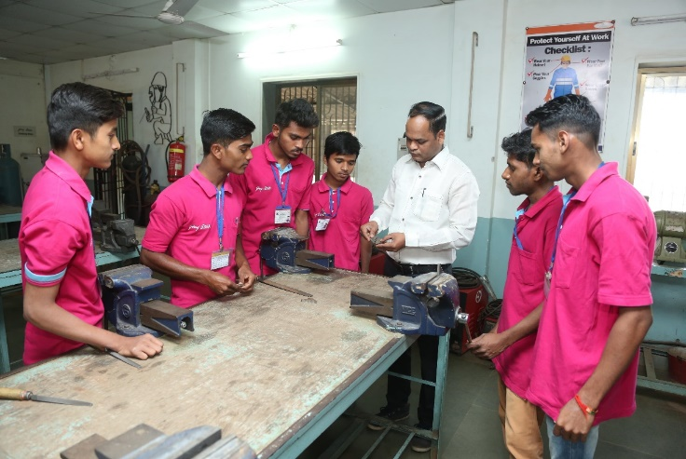

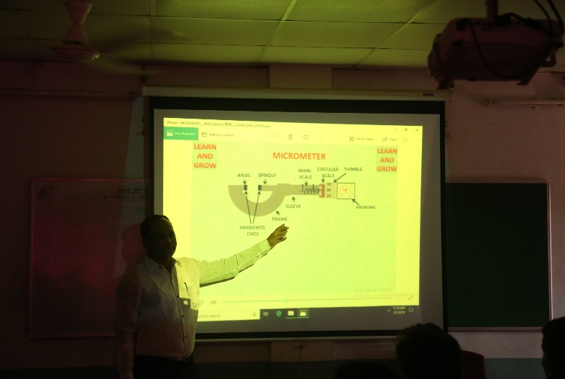 **Fitter Practical 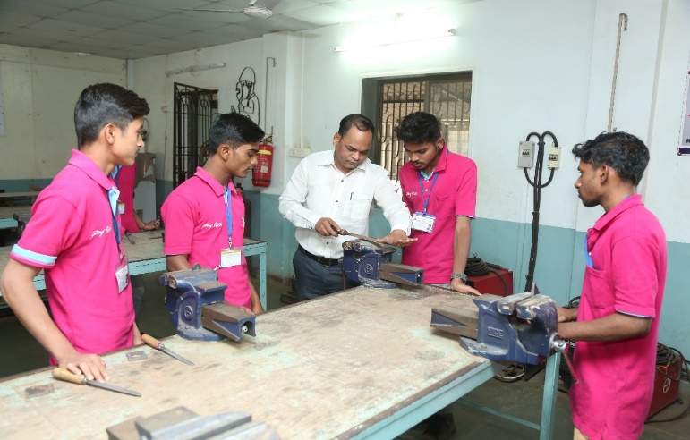 Fitter Practical**

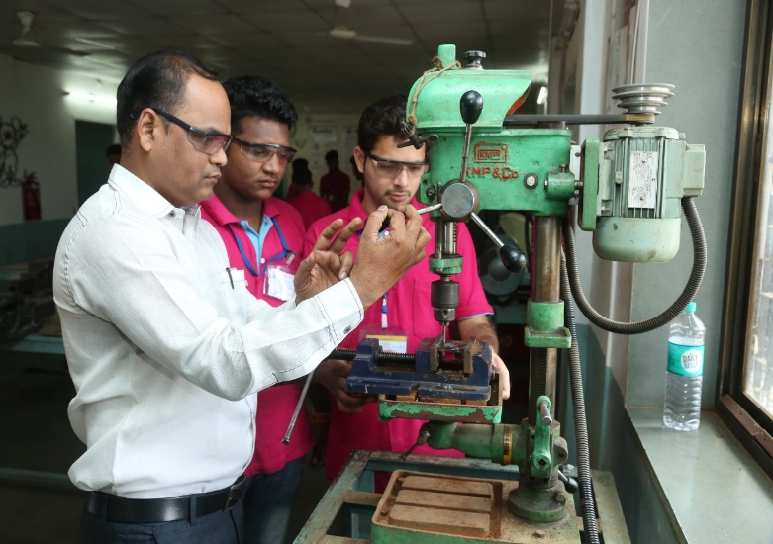

**Fitter practical**

**Theory Class**

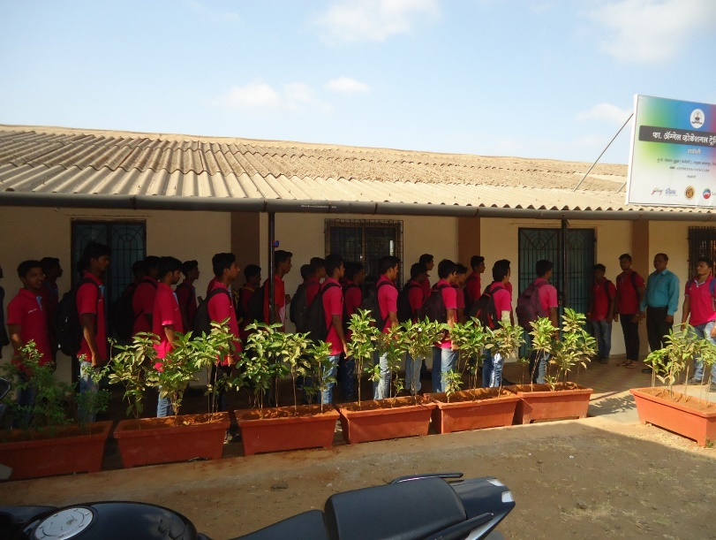**Daily Morning & evening prayer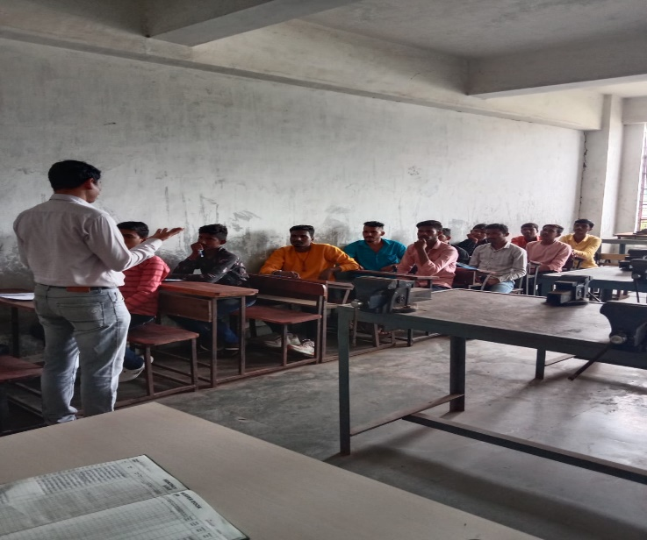 Theory Class**

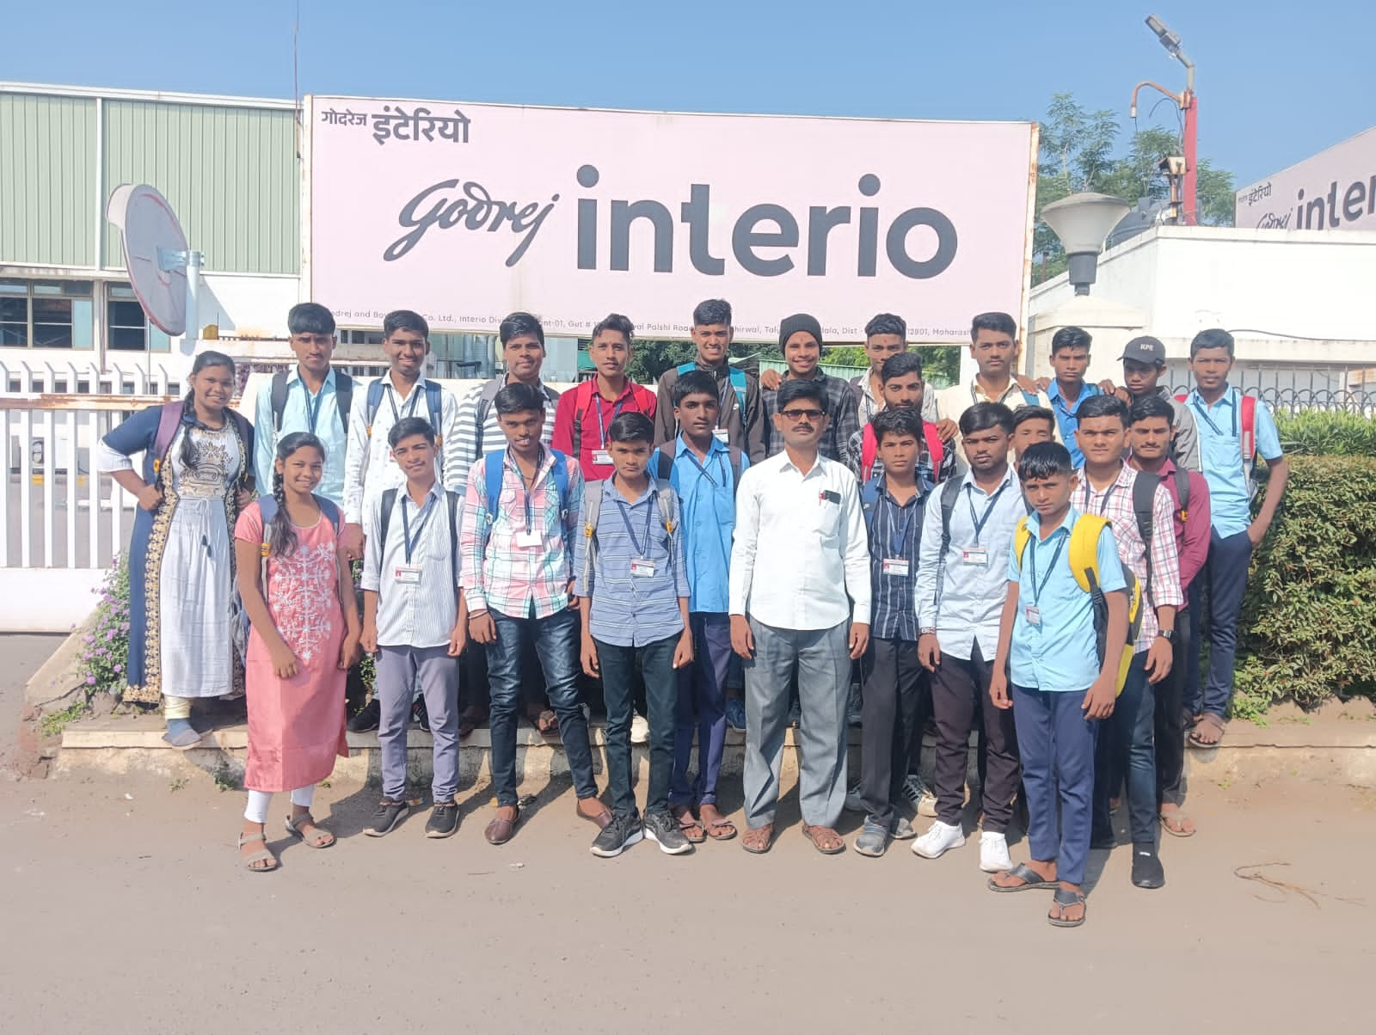

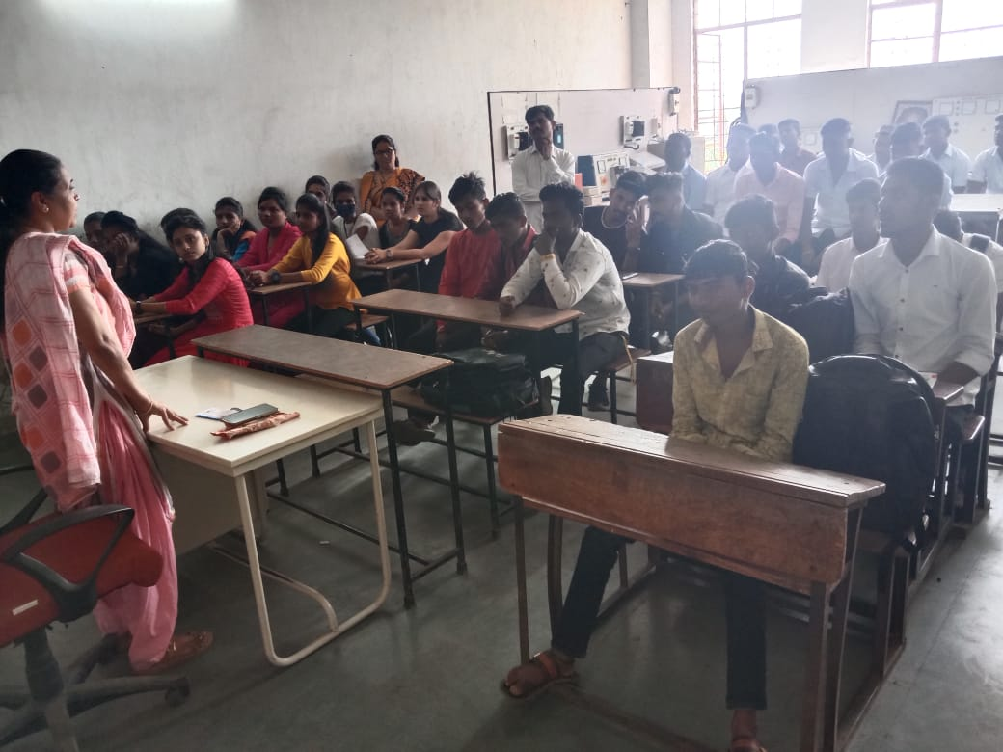

**Industrial Visit Bank Person Lecture**

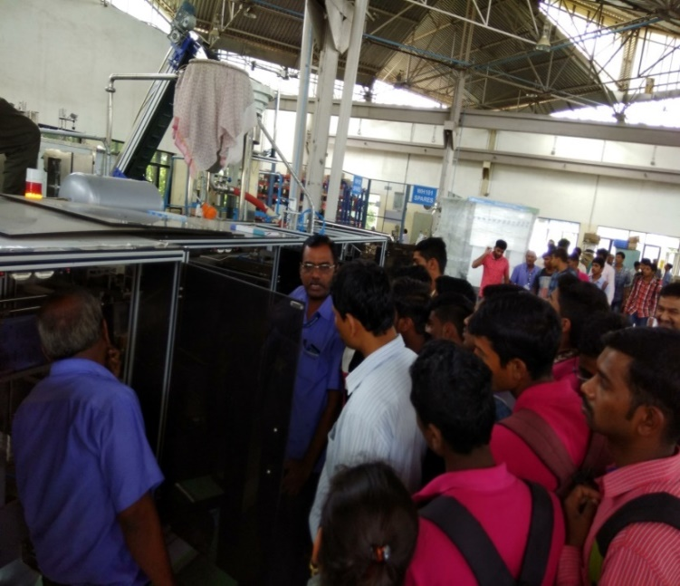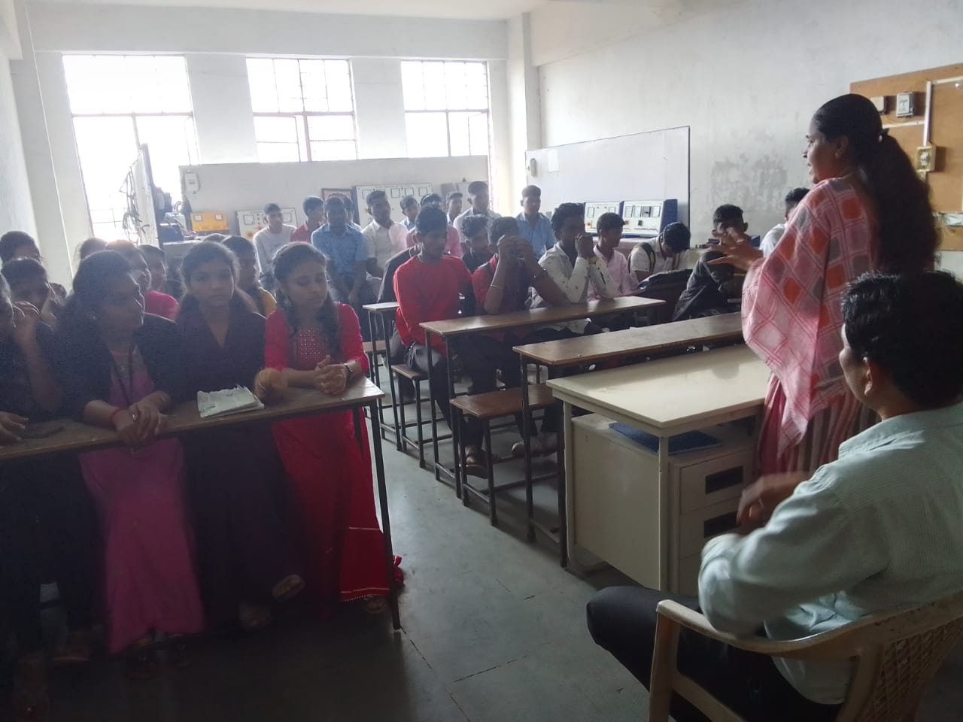**Industrial Visit Bank Person Lecture**

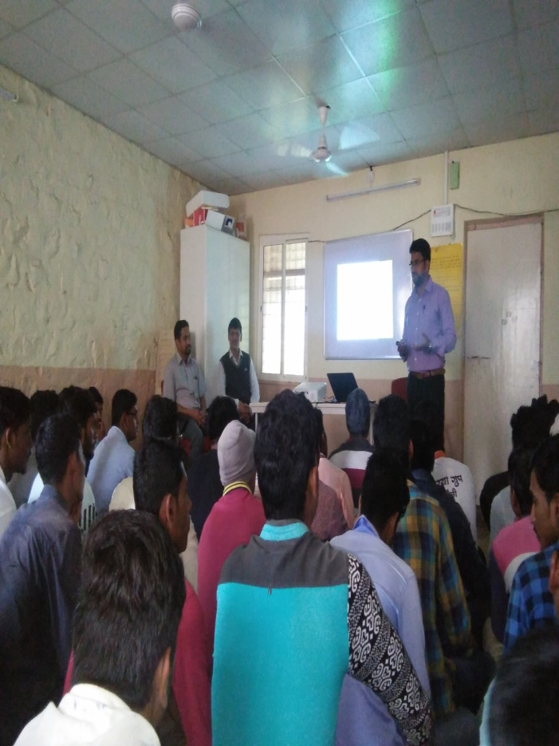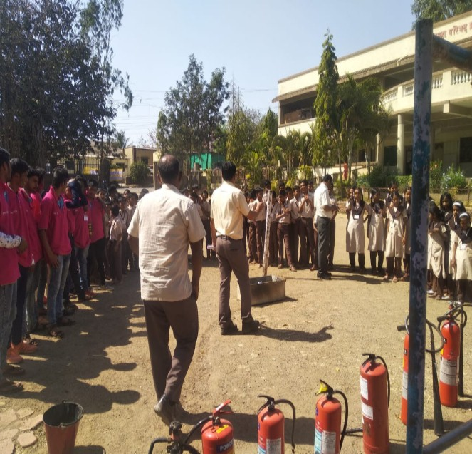 **Workshop Fire & Safety**

**Workshop resume writing**

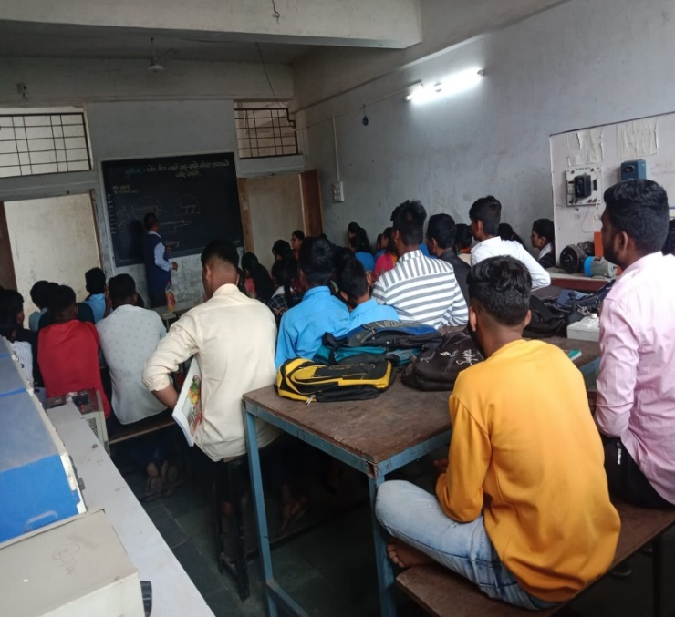

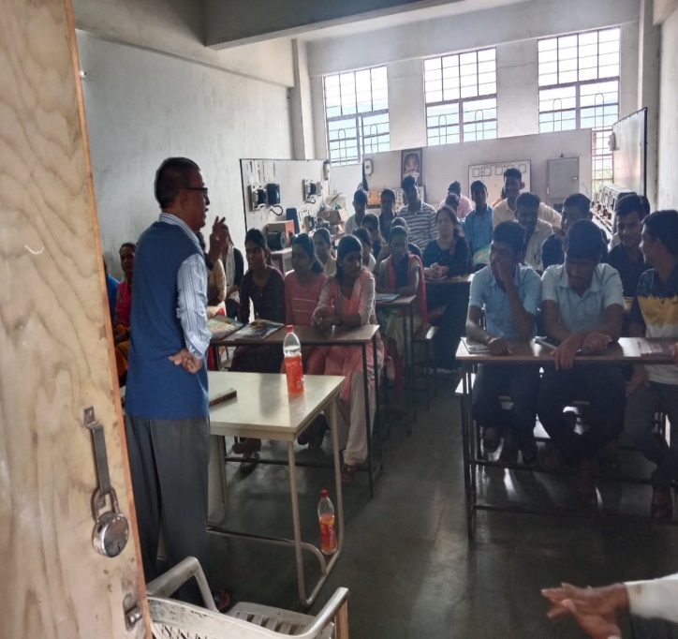

**English Specking Lecture English Specking Lecture**

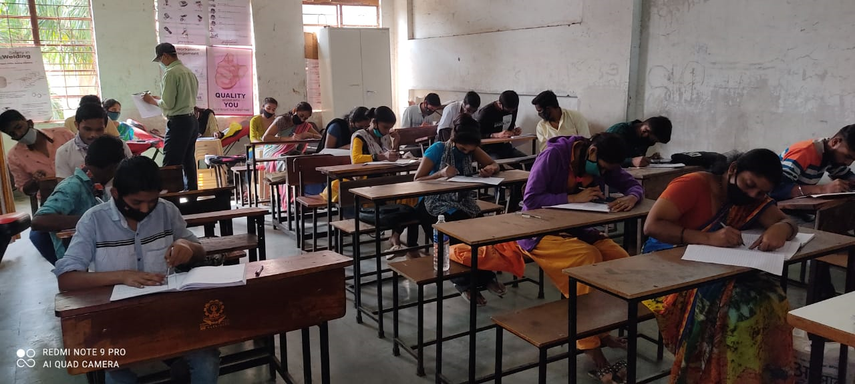 **Unit Test**